Can Bodybuilding Provide an Answer to Doping Issues in Sport?

The ever-present threat of doping scandals threatens to undermine many great sporting events, and has claimed the career of many an athlete. Whilst WADA (the World Anti-Doping Federation) have endeavoured to lead the fight against old and new banned substances, against the emerging threat of blood doping, and against the bio-pharmaceutical development of more and more new (and undetectable) substances, the incidence of doping remains prevalent across many elite sports.
As sports federations look to new ways to fight the problem, one unlikely source emerges as potential inspiration – or at least as an interesting source of debate – the world of bodybuilding.
Casual observers of the sport of bodybuilding would be forgiven in thinking that the sport relies almost completely on the use of performance enhancers such as anabolic steroids in order for competitors to achieve a ‘freaky’ muscular look. However, if one looks a little closer, a fascinating juxtaposition of two worlds exist; the natural and assisted world of bodybuilding.
The natural world of bodybuilding consists of federations that demand that athletes are drug-free and that they have made a lifetime commitment to drug free training in order to be eligible to compete. Many natural federations are WADA compliant, and many also rely on blood testing, urine testing and polygraph testing.
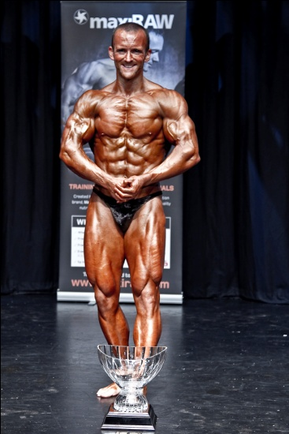
The ’assisted’ world of bodybuilding consists of federations that are not WADA compliant and where the use of banned substances is more prevalent. Both sides of the sport (at amateur level) are represented by multiple federations, and both offer routes to regional, national, European and international competitions that are viewed as highly prestigious in amateur circles. A commitment to achieving success within either side of the sport takes immense dedication, as it does in any sport.
The development of a natural and assisted route offers an intriguingly clear acknowledgement to athletes and fans that drugs do exist, that they are used, and that they will remain within the sport. Thus, one can surmise that the response by the bodybuilding community towards the use of performance enhancing substances appears to be one of pragmatism, not denial.
Whilst a small minority of cheats may still exist within natural federations, the very fact that bodybuilding athletes have 2 routes open to them from the outset – natural or assisted – makes it far easier for natural federations to police drug taking, and gives athletes greater control and choice within their competitive careers. Effectively, this approach seeks to level the playing field as much as possible. It is an interesting system, as it has the effect of allowing competitors to feel no pressure to engage in the use of performance enhancers to rise to the top of the sport, and provides a clear dialogue around the concept of steroid use.
We speak to reigning British natural bodybuilding champion, Mark Oakes, and former World champion, Tony Montalbano, for their opinions and experiences surrounding this highly contentious and controversial issue.

Case Study

Can Olympic sport learn from bodybuilding?

WOMENS PARTICIPATION IN THE OLYMPIC GAMES
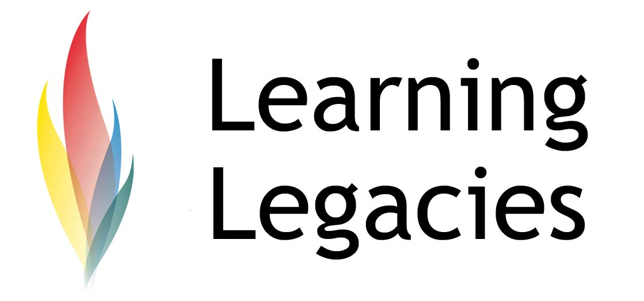

- Please outline the highlights of your competitive career.
M: I completed for the first time at the age of 19 in the South East qualifier for the ANB (Association of Natural Bodybuilders) and came second, thus qualifying for the British Finals. Since then I have competed more or less alternate years. The highlights so far been: 2002 – ANB u80kg British Champion; 2005 – NPA Overall British Champion; 2007 – UIBBN u75kg World Champion; 2011 – UK DFBA Open UK, u80 Kg Champion, and 2011 – NPA Overall British Champion
T: I have been competing since Sep 1997 where I debuted as ANB Central England (debut) Novice 3rd place winner. I won my first (of many) regional championships in 1998, and my 1st national championship in 2003 (A.N.B Wales 03 1ST & best presentation winner; A.N.B U.K Championships 1st, best presentation winner and overall winner; A.N.B British finals 1st place). I competed on the world stage in the U.I.B.N Worlds to win 2nd place; then won the NPA Mike Williams classic overall & the Pro-am before going on to win the NPA British Finals the UIBBN Worlds (3rd place). I then won 1st place at the Musclemania World Championships to secure my title as a World Champion.
- What attracted you to the sport of amateur bodybuilding?
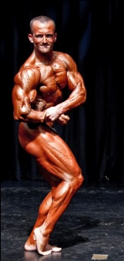
M: I was always involved in sports from a young age, starting gymnastics and 4 and Karate at 7 years of age. Playing Rugby at school, the gym and strength training complemented all the sport I was involved in at the time. It was when I was training at the local YMCA that i was introduced to the idea of “Natural Bodybuilding” and those around me convinced me that I might do well. I decided to give it a go, really enjoyed the whole experience, and never considered stopping ever since!
T: I always wanted to get in shape & never had the motivation to do it so this definitely made me be the best I could be

- What keeps you coming back to compete?
M: I am competitive by nature. I have always been involved in sport and am competitive in other areas of my life, such as work, as well. Bodybuilding does not have to be a competitive sport and many choose to pursue the lifestyle away from the stage. For me, the competition is an extra element of the lifestyle and can give a real focus. It is an opportunity to set very real and measurable goals to pursue. The excitement of competing drives me to return. Additionally, I have made several close friends through the competitive side of the sport and the camaraderie is amazing. I have been fortunate enough to compete successfully and it is a very positive experience to be able to compete at the highest of levels, in an activity which is after all, a hobby.
T: Well I have retired now but the goal was to win the British, then it was the Worlds.

- How does training for bodybuilding competitions affect your life (in terms of a commitment to training, etc)?
M: I am an organised, disciplined and motivated individual, in my opinion. Bodybuilding competitions fit well

Case Study

Can Olympic sport learn from bodybuilding?

WOMENS PARTICIPATION IN THE OLYMPIC GAMES
into my life, since I feel that it is just a matter of being organised. This is evident in terms of training, food preparation and all the aspects involved in contest preparation. The focus can also provide a real break from the hectic life of work and in a bizarre way drives me to excel in other areas away from bodybuilding, to ensure that nothing in life slips. Although some compromises do need to be made for the period of time I get ready for a contest and the season, which may well be 16 to 20 weeks. During this time I will not go out for dinner or eat food which is not part of my diet plan and my social life and therefore that of my fiancée can be compromised. However, we are both cognisant that this is for a defined period of time and make up for it away from the season.
T: You basically live in the kitchen it’s a very lonely sport. It’s a selfish sport. I think it is definitely easier if you are single. You only have enough energy to train & little for anything else.

- At the outset of your competitive career, you could have chosen to be a natural bodybuilder (i.e. to compete in a drug-free federation) or an assisted bodybuilder (i.e. to compete in a federation where the use of performance enhancing substances is more prominent). You chose to compete in a natural, drug-tested federation. Why is this?
M: In all honesty, taking the assisted route was never something that really occurred to me, since those around me were also natural, although I have considered it since. For me, bodybuilding is a hobby. I am pleased that I can compete successfully at a high level and have made gains in terms of size, strength and condition over the 25 years I have been training, which are evident for all to see. Since I have never taken any performance enhancing drugs, I have preferred to compete on the natural/drug-free stage, since clearly I am more likely to do well with this being a level playing field. If I had taken the assisted route, it would have been when I was much younger, to see how far I could go in the sport. Given that I have a very driven personality, there would have been potential health risks to have considered. I am happy taking the sport and lifestyle as seriously as I do, but naturally. In many ways, being natural makes me more of a “freak” in many gyms where competitive natural bodybuilders are by far the minority, in my opinion. I enjoy being the “freak” element and showing just how far you can take the body naturally, with to be honest, fairly average genetics.
T: Because I trained to be healthy & that would be defeating the object. Also I never wanted to get massive. I always like the Zane type physique.

- One of the major challenges facing the Olympic federation is the control of doping. How is doping monitored in your federation?
M: I compete in different natural/drug-free federations. Drug use is controlled by a mix of WADA approved urine testing and/or polygraph testing.
T: Lie detector & urine tests

- Do you feel that the existence of both a natural and assisted route has helped to control the problem of doping and drug cheats in bodybuilding?
M: Not really, from where I see it, there is more drug use in gyms now than ever there was. I see lots of individuals taking performance enhancing drugs who neither compete nor have reached anywhere near their natural potential. Importantly, I do not see that there are “drug cheats” in bodybuilding, other than athletes who compete in drug-free contests when they are not. If the federation in which an athlete competes does not have these rules, then its athletes should NOT be considered “cheats” in my opinion. It is simply a different set of rules for a different set of athletes. I do feel that natural bodybuilding provides an avenue for natural athletes to compete against like-minded bodybuilders, on a level playing field, with these athletes pushing themselves just as hard as assisted athletes.
T: Yes but I still think people who did drugs in the past still compete in tested shows as they feel they are

Case Study

Can Olympic sport learn from bodybuilding?

WOMENS PARTICIPATION IN THE OLYMPIC GAMES
natural. Or even cheat.

- What doping tests have you been subject to within your competitive career?
M: Urine and polygraph
T: Lie detector & urine tests

- Amateur bodybuilding is the only sport in the world where there is a clear route & a clear choice to pursue a natural (WADA compliant) or assisted route. Why do you think this is?
M: Since bodybuilding is so closely linked with drug use and the levels of drug use can be so extreme, for some individuals, it is no surprise that some individuals have chosen not to use drugs. Consequently drug-free contests are inevitably going to evolve from individuals’ desire to compete on a level playing field.
T: Because bodybuilding is known for drugs than anywhere else

- Do you think that development of the two routes has benefited or hindered the sport?
M: I don’t feel it has had any impact whatsoever on sport in general. Competitive bodybuilding is in itself a minority sport which is generally misunderstood by those not close to it. Natural bodybuilding is a minority within this. If there was greater public awareness of bodybuilding and the distinction that exists between natural and bodybuilding (since it is generally not referred to as “assisted” away from the natural community), it would most likely result in questions being asked of many other (Olympic) sports where it is assumed that everyone except a minority are drug-free.
T: Benefited as it’s good for both to have competition so they always try to improve.

- Do you think that your experience as an athlete within the sport would be notably different if bodybuilding only had one route to follow (i.e. no natural AND assisted federations), as is the case with other sports?
M: If I competed naturally within “assisted” federations, I would have some degree of success, and have done this on one occasion. But ultimately I would have achieved less in terms of titles and events which I have won, since the advantage in bodybuilding which drugs provide, is too great. In this regard I would have had a very different experience with regard to competition.
T: Yes I wouldn’t have competed.

- Do you feel that Olympic sports such as cycling (that historically have demonstrated a prevalence of doping) would benefit from adopting the same approach that bodybuilding has taken?
M: Yes. But I do not feel that neither the public nor Olympic committee are ready to accept or admit that there is the level of drug use in sport, which perhaps exists.
T: Yes.

- Do you think that other sports would ever adopt the approach used by bodybuilding?
M: No. It is easier perhaps better to drive for drug-free competition across the board, as opposed to endorse an “assisted” route by turning a blind eye. Otherwise the potential result could be two “types” of federation for almost every sport.
T: Yes.

- Do you feel that the existence of both routes in the sport (natural and non-natural) is a positive thing for the athletes/the sport?
M: In bodybuilding, I believe this is a good thing, since it allows athletes to make choices which they are

Case Study

Can Olympic sport learn from bodybuilding?

WOMENS PARTICIPATION IN THE OLYMPIC GAMES
comfortable with and compete in this arena.
T: Yes.

- What might your advice be for other sports that look to bodybuilding with interest, in terms of potential adoption of a natural and assisted route?
M: Ensure you have the support of the athletes to adopt this approach and the budget to enforce a strong drug-testing program.
T: Just be the best you can be and remember it’s just 5 or 6 judges who have different opinions of what a great physique is.

- Many believe that athletes are role models for young people. Do you think this is true of natural and assisted bodybuilders?
M: All successful bodybuilders train hard, are disciplined and organised. The training involved which is predominantly strength based, is beneficial for muscle and bone health. Additionally, some aspects of bodybuilding training are also of benefit to the heart and lungs as well as the immune system. I would imagine that all bodybuilders eat more consistently healthily than their non-sporting peers, smoke and drink, on average less (although I have no data to support this). These are all qualities which I believe young people should be encouraged to aspire towards. Issues of personal choice and behaviour do not define bodybuilders, whether they be natural or assisted.
T: Yes as it involves discipline & persistence

- Bodybuilding is often stereotyped as a sport that attracts vain individuals, and which promotes body dysmorphia. What is your opinion of such stereotypes?
M: Stereotypes exist within society. Whether they be related to sports, jobs, politics or any other aspect. I try to avoid being a stereotype and equally try to avoid judging others in the same way. I aim to respect others for the qualities they demonstrate and hope to inspire others in the same way.
T: Well it is about vanity, we all want to look good. But the bonus is you will be healthier & more confident.

- As a coach, do you actively try to steer young bodybuilders towards a natural route? If yes, how do you achieve this?
M: I tell them straight the side effects to steroids. That you can still achieve a great physique without drugs but be healthier

Discussion
- Research recent Olympic drug scandals at the Athens and Beijing Games. Discuss the cases that you have found and consider whether the problem appears more prevalent in some sports more than others.
- What are the greatest threats currently facing WADA in terms of the policing of banned substances at the Olympic Games?
- The use of a natural and assisted route is unheard of in any sport other than bodybuilding, although drug use appears to be a problem across many, if not all, sports. Do you feel that other sports would benefit from the approach that bodybuilding has taken?

Case Study

Can Olympic sport learn from bodybuilding?

WOMENS PARTICIPATION IN THE OLYMPIC GAMES

Case Study

Can Olympic sport learn from bodybuilding?

WOMENS PARTICIPATION IN THE OLYMPIC GAMES

- Do you feel that it is better for the image of a sport to acknowledge the use of performance enhancing substances, and to attempt to regulate its use, or do you feel it is better to deny problems in order to present a positive image to young fans of the athletes?
- Do you feel that athletes who test positive for banned substances deserve a 2nd chance at competing, or do you think that they should be banned for life?
- If WADA lifted the ban on all performance enhancers, would it then be right for athletes to take them?
- You are offered a performance enhancer that no-one has ever taken before, or even discovered. As such, it does not appear on any banned substance lists. You know it will give you a massive competitive advantage over your competitors. Would you take it?
- In the scenario above, would the choice to take the enhancer be moral? Please justify your answer.

Further Information
WADA: www.wada-ama.org
Natural Physique Association: www.npabodybuilding.com
BNBF: www.bnbf.co.uk

Case Study

Can Olympic sport learn from bodybuilding?

WOMENS PARTICIPATION IN THE OLYMPIC GAMES

This resource was produced as part of the 2012 Learning Legacies Project managed by the HEA Hospitality, Leisure, Sport and Tourism Subject Centre at Oxford Brookes University and was released as an Open Educational Resource. The project was funded by HEFCE and part of the JISC/HE Academy UKOER programme. Except where otherwise noted above and below, this work is released under a Creative Commons Attribution only licence.

Exceptions to the Licence
The name of Oxford Brookes University and the Oxford Brookes University logo are the name and registered marks of Oxford Brookes University. To the fullest extent permitted by law Oxford Brookes University reserves all its rights in its name and marks, which may not be used except with its written permission. The JISC logo is licensed under the terms of the Creative Commons Attribution-Non-Commercial-No Derivative Works 2.0 UK: England & Wales Licence. All reproductions must comply with the terms of that licence.

The Higher Education Academy logo is owned by the Higher Education Academy Limited and may be freely distributed and copied for educational purposes only, provided that appropriate acknowledgement is given to the Higher Education Academy as the copyright holder and original publisher.

Reusing this work
To refer to or reuse parts of this work please include the copyright notice above including the serial number. The only exception is if you intend to only reuse a part of the work with its own specific copyright notice, in which case cite that.

If you create a new piece of work based on the original (at least in part), it will help other users to find your work if you modify and reuse this serial number. When you reuse this work, edit the serial number by choosing 3 letters to start (your initials or institutional code are good examples), change the date section (between the colons) to your creation date in ddmmyy format and retain the last 5 digits from the original serial number. Make the new serial number your copyright declaration or add it to an existing one, e.g. ‘abc:101011:011cs’.

If you create a new piece of work or do not wish to link a new work with any existing materials contained within, a new code should be created. Choose your own 3-letter code, add the creation date and search as below on Google with a plus sign at the start, e.g. ‘+tom:030504’. If nothing comes back citing this code then add a new 5-letter code of your choice to the end, e.g.; ‘:01lex’, and do a final search for the whole code. If the search returns a positive result, make up a new 5-letter code and try again. Add the new code your copyright declaration or add it to an existing one.

(NB the term ‘assisted’ is generally used only by the natural community to denote the difference between the two types of competition. What is referred to here as ‘assisted’ is simply referred to as ‘bodybuilding’ by those who compete in federations that are not explicitly called ‘natural federations’).

